Data Technician Workbook
Week 1: Excel

Name:
Course Date:
Table of contents
Day 1: Task 1 2
Day 2: Task 1 2
Day 2: Task 2 3
Day 2: Task 3 4
Day 3: Task 1 4
Day 3: Task 2 5
Dataset: 5
Step 1: Create a Pivot Table 5
Step 2: Use the SWITCH Function 5
Submission: 6
Day 3: Task 3 6
Day 4: Task 1 7
Course Notes 9
Additional Information 10

Day 1: Task 1

Please research and complete the boxes below on common laws and regulations that must be followed when working with customers' data, and use the below bulleted list to support your answers.

- What is it
- Why is it important
- Provide a real-world example of how you can follow it
- How does it impact working with data
- What could happen if you breached it

Data Protection Act | The Data Protection Act 2018 includes rules by which organisations must follow when it comes to handling personal data. This includes provisions on what organisations can use data for, how long it can be kept and how it must be stored — there are stronger protections when it comes to sensitive data, such as race, religious beliefs and biometrics. The general public have also been given the right to find out what data organisations are keeping on them and what it’s being used for in some circumstances.  This is to prevent the general public’s personal data from being misused or falling into the hands of criminals. For data professionals, it’s important to follow the Act’s regulations to avoid facing criminal prosecution.
GDPR | GDPR stands for General Data Protection Regulation and was a measure passed by the European Union in 2018. It is intended to give individuals greater control over their personal information, while offering organisations greater clarity over how they can use and store personal data — this includes requirements for organisations to document how it uses personal data, while also giving individuals the right to access their personal data being kept if requested. The UK introduced the same legislation after leaving the EU. Any organisations handling personal data must follow GDPR, with potential breaches to be investigated by the UK Information Commissioner’s Office and potential fines levied if a violation is found to have occurred.
Freedom of Information Act | The Freedom of Information Act was passed in 2000 and gives individuals the right to request recorded information held by UK public institutions, with some exemptions relating to national security and economic interests. Individuals and businesses can make Freedom of Information requests, which are overseen by the Information Commissioner, an office established as part of the Act. When releasing the requested information, care has to be taken not to accidentally release personal data and risk a breach of the Data Protection Act, which has happened in the past. Personal data needs to be stored properly to ensure quick access can be made in the event of a FOI request.

Day 2: Task 1

Please research and complete the following tasks within the retail-sales_dataset.xlsx document, and paste a print screen into the provided boxes below:

- In the sheet ‘retail_sales_dataset’, add all available data between columns A – H into a ‘table’ using Ctrl+T. Then name the table.
- Using the ‘filter’ function, filter ‘Age’ from ‘largest to smallest’
- Using the ‘SUM’ function, show me the commission total in cell ‘P10’
- Using the ‘AVERAGE’ function, show me the average commission in cell ‘P11’

Print screen 1 | 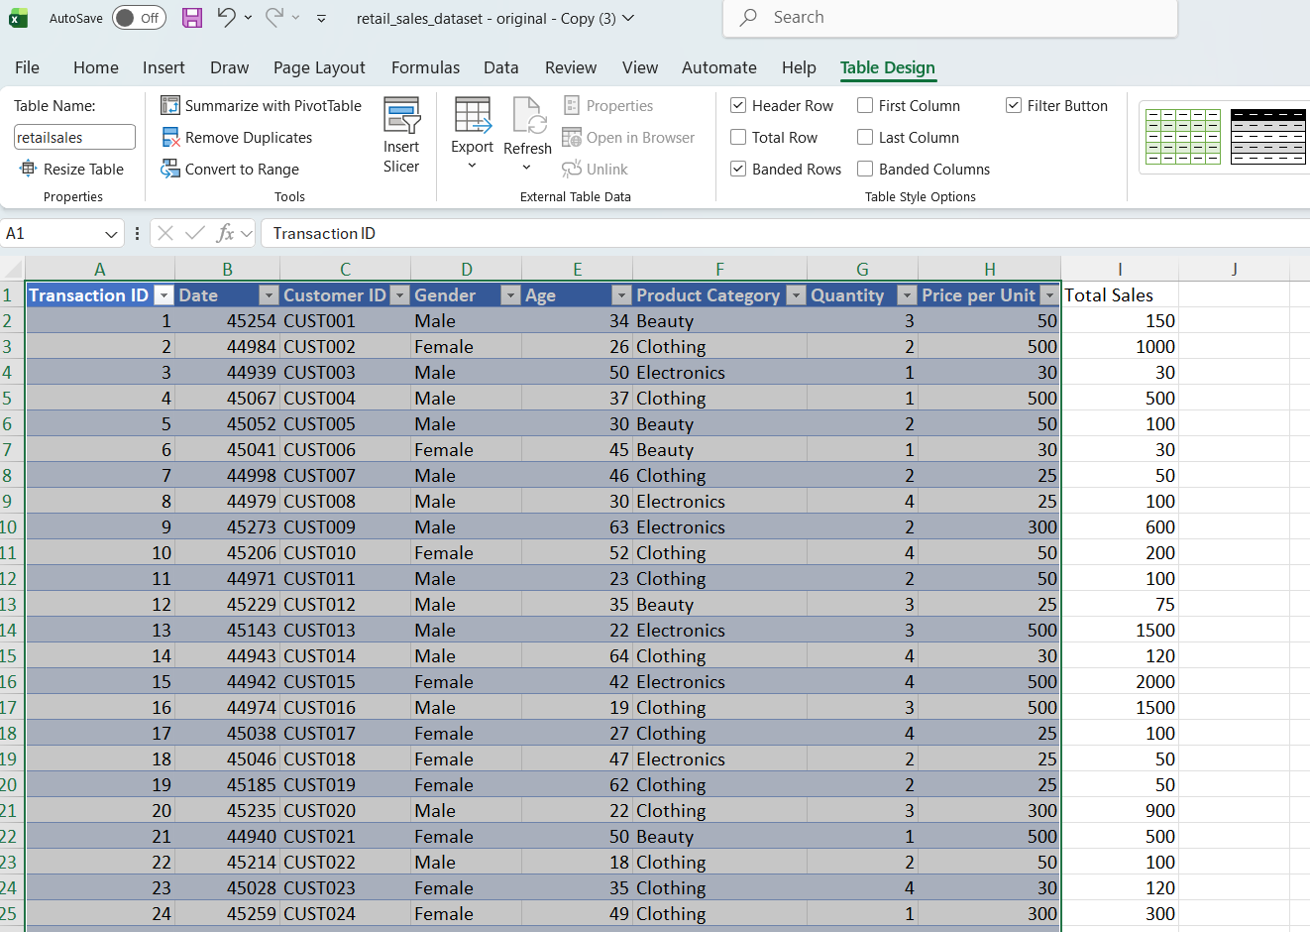
Print screen 2 | 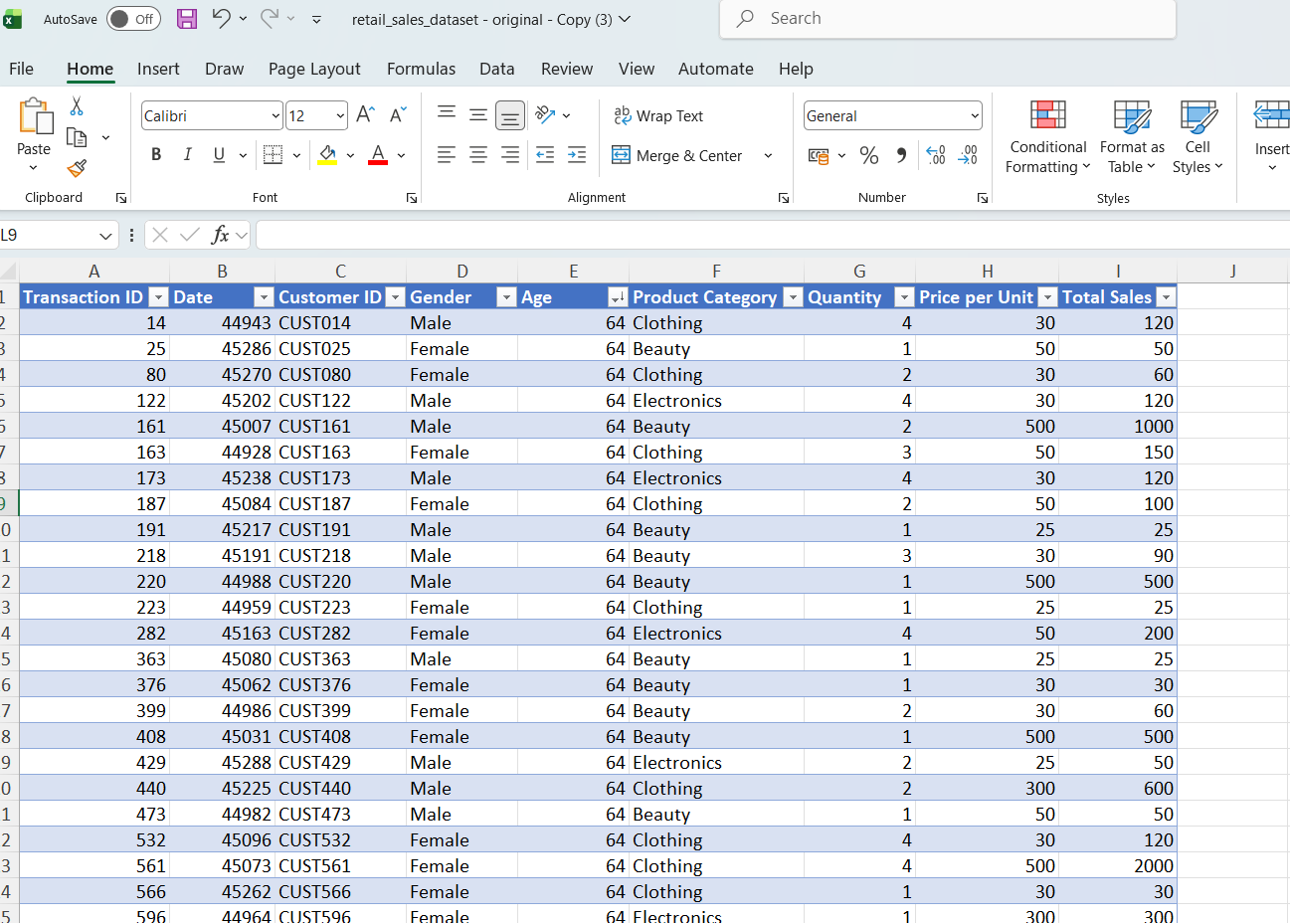
Print screen 3 | 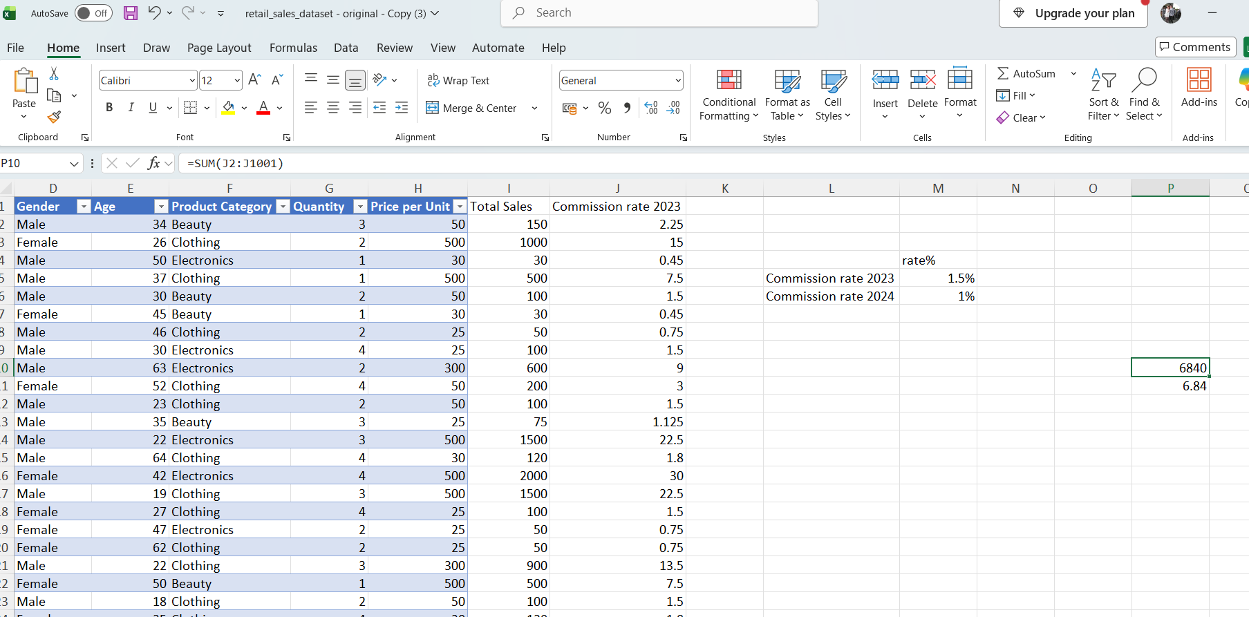
Print screen 4 | 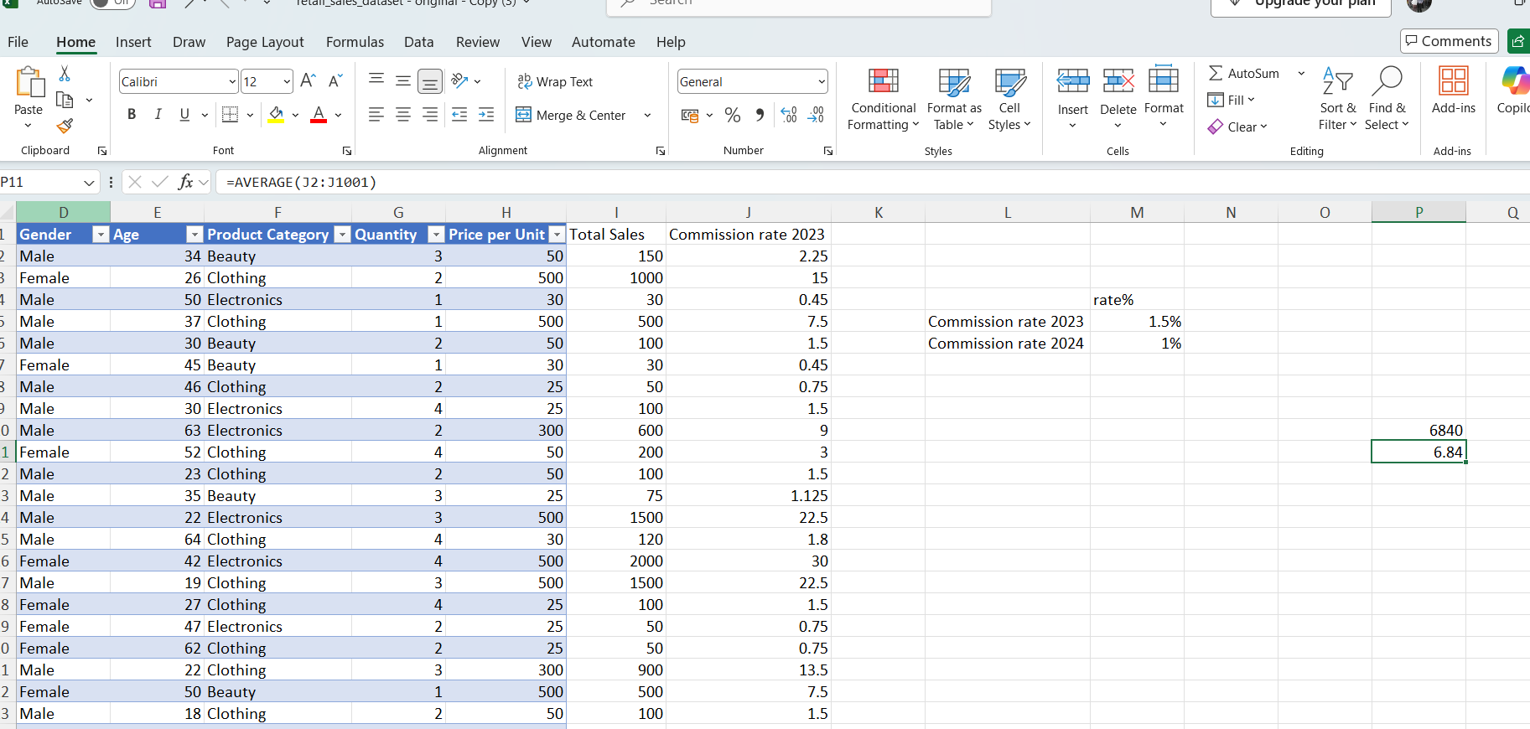

Day 2: Task 2

Please research and complete the following tasks within the document, and paste print screens into the provided box below:

Use the Student grades table provided by the tutor,

Convert the table to an Excel table. (Ctrl +T)

Student name | English | Mathematics | Science | Average | Highest score
Carol | 75 | 85 | 85
Khan | 85 | 75 | 80
Harry | 80 | 70 | 80
Sarah | 80 | 70 | 80
John | 65 | 80 | 70
Linda | 90 | 50 | 70
Edward | 55 | 80 | 60
Mary | 55 | 70 | 65
Thomas | 55 | 30 | 65

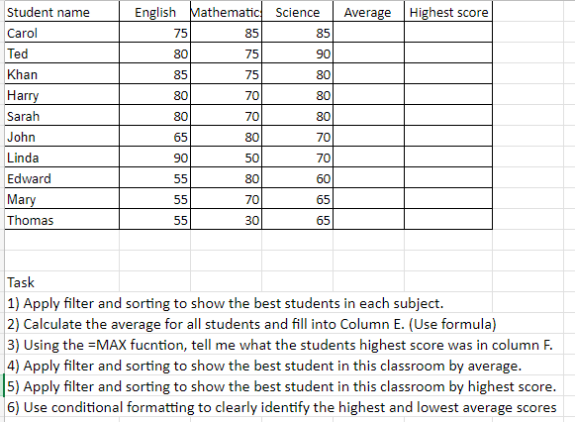

Print screen 1 | 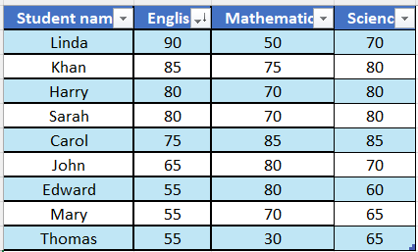  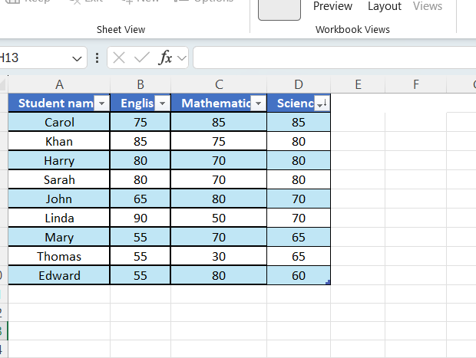  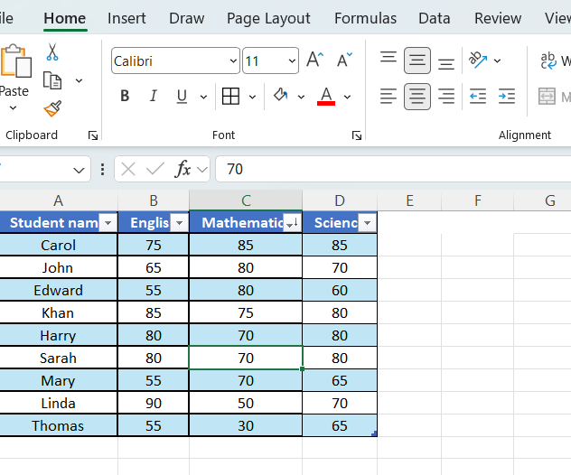
Print screen 2 | 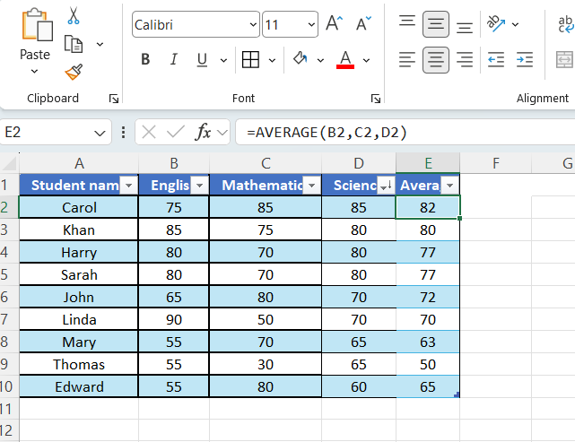
Print screen 3 | 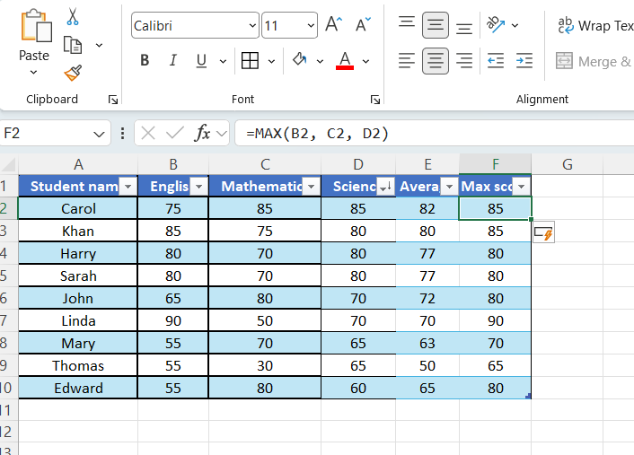
Print screen 4 | 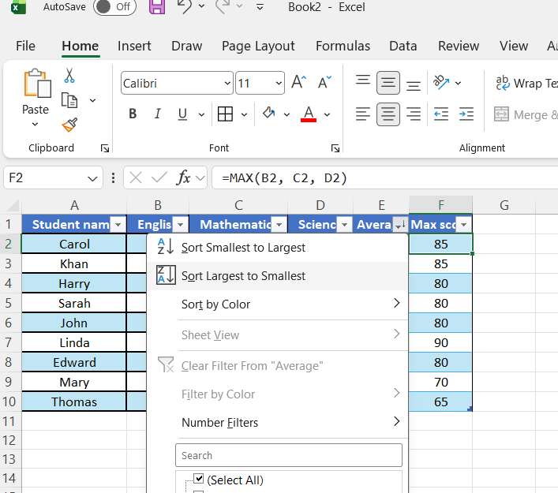
Print screen 5 | 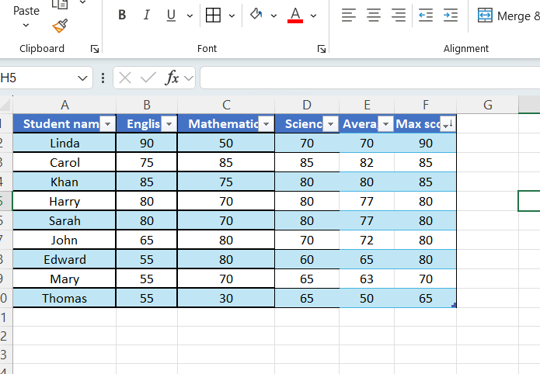
Print screen 6 | 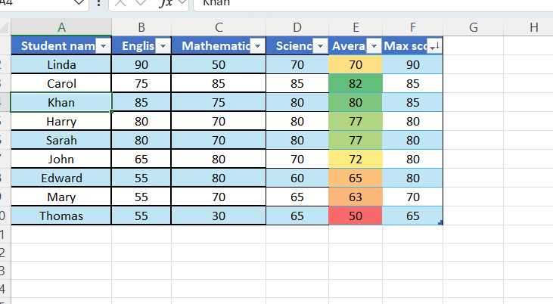

Day 2: Task 3

Using the skills developed today, have some fun with the data set you have imported. Paste your work below and enjoy!

Print screen 1 | 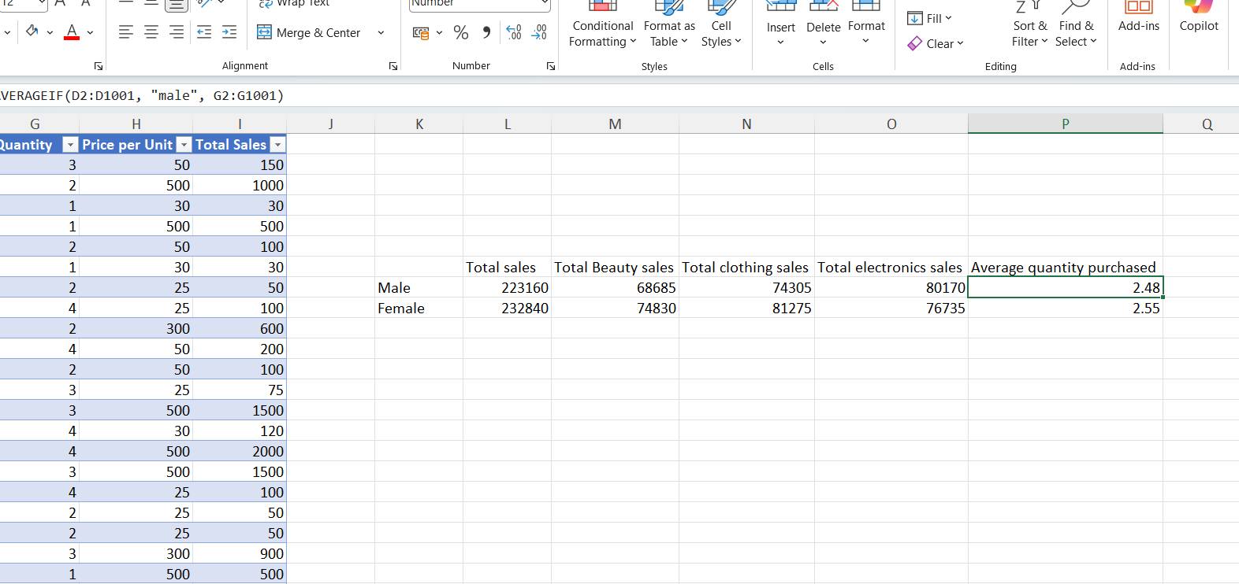

I wanted to look at the gender difference in the dataset, so I used a SUMIF formula to find the total sales by male and female. I proceeded to use SUMIFS formula to split the total sales by both different categories and genders. Finally, I wanted to see whether males or females purchased more items — using an averageif formula, I can see that they tend to buy the same quantity of items on average.

Day 3: Task 1

Dataset: Day_3_Task_1_Bike_Sales_Pivot_Lab.xlsx. and,
Lab instructions: Lab pivot table use for task 1 instructions

Make a copy of the dataset. Use the copy.

Convert to Excel Table (Ctrl +T)

Follow the lab instructions. Do not worry if you do not complete the lab; just working with data and playing with the pivot table will be a good experience.

Note:
Under refine the pivot table:
To mask 0's.
Click the pivot table
Click the Pivot Table Analyse tab on the menu bar.
Options > options > layout and format> In the field for empty cells, select the checkbox and enter 0 (zero). Ok.

And for the reflection questions, please do them in your workbook, not in the lab.

Please paste your final pivot table below and complete the reflection questions:

Print screen 1 | 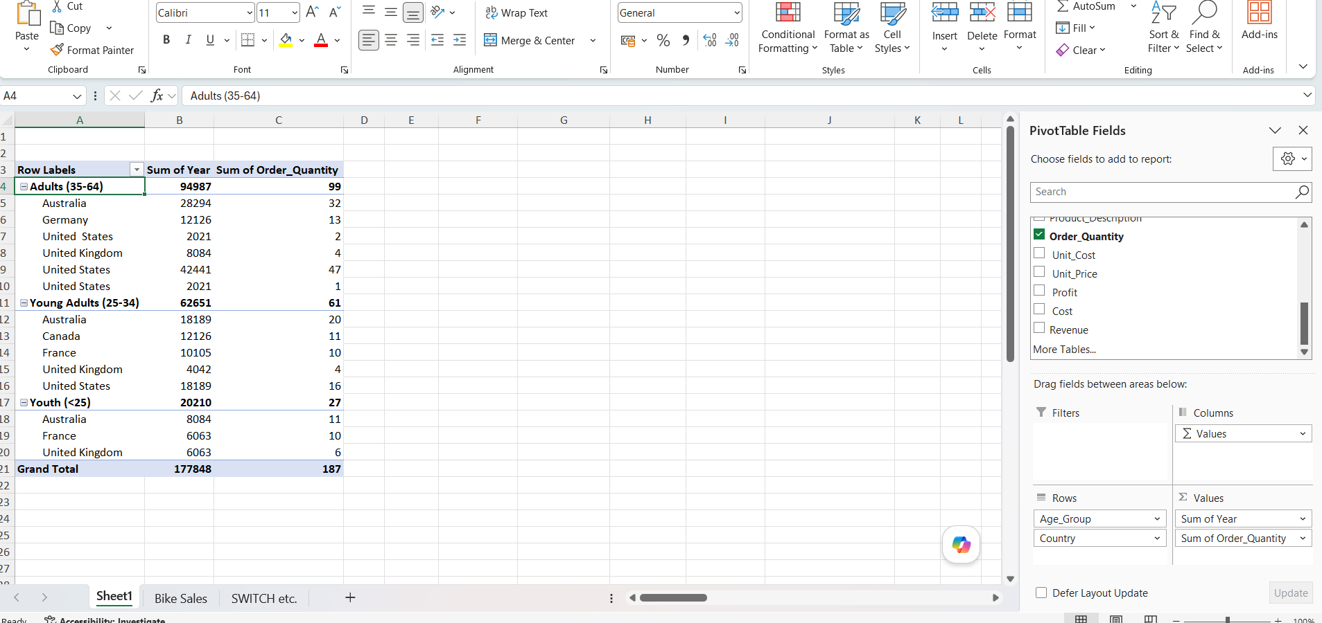
In which markets does Germany have customers? | Germany only has adults aged 35-64 as a market, as seen from the below pivot table  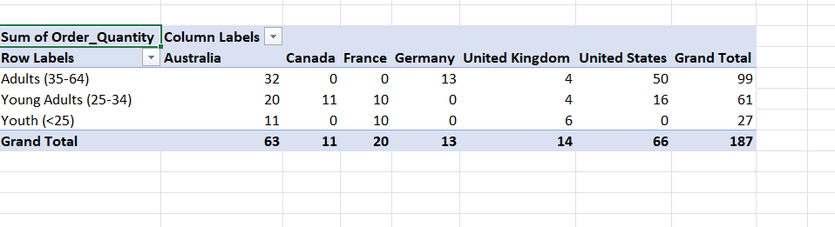
What country has sales in all markets? | Using the pivot table above, it’s possible to see that Australia and the United Kingdom have sales in all markets, as indicated by these countries having quantities for all three market segments. Canada, France, Germany, and the USA are missing data for entire market segments.  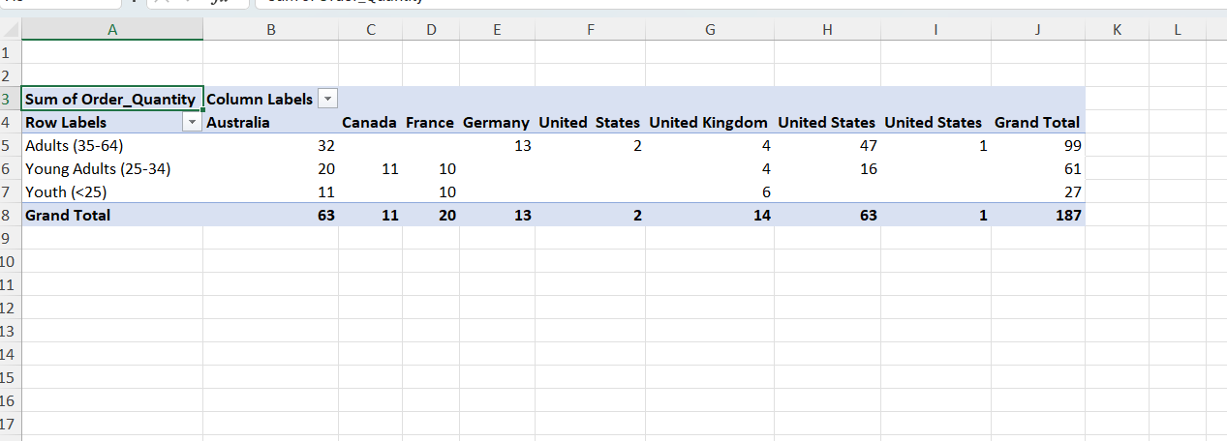
What are the most profitable markets by country, age group, and gender? | By country: United States is the most profitable market by country, as seen by this sorted pivot table  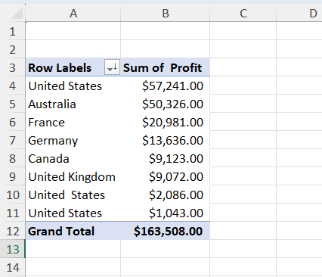  By age group: Adults 35-64 are the most profitable market, as seen by the sorted pivot table below  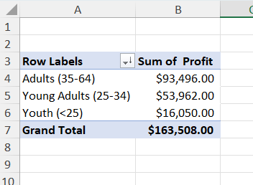  By gender: Females are the most profitable market, as seen by the pivot table below  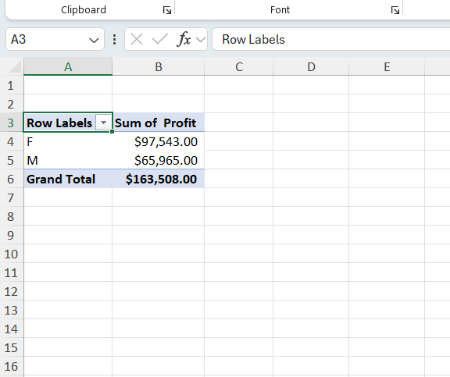
Any other findings?

Day 3: Task 2

The dataset below tracks the sales performance of different products in various counties in England. Please paste the dataset into a blank Excel workbook. Your task is to:
- Create a Pivot Table to summarise the data by county and product.
- Use the SWITCH function to categorise products based on their sales volume.
See instructions below.

The dataset can be found in the last workbook you used.

County | Product | Sales Volume
Yorkshire | Laptops | 500
Yorkshire | Smartphones | 200
Cornwall | Laptops | 700
Cornwall | Printers | 400
Lancashire | Smartphones | 150
Lancashire | Laptops | 600
Essex | Printers | 800
Essex | Smartphones | 300
Durham | Laptops | 250
Durham | Printers | 300
Greater Manchester | Smartphones | 600
Greater Manchester | Laptops | 400

Dataset:

Step 1: Create a Pivot Table
- Select the dataset (columns A to C).
- Insert a Pivot Table to summarise the data by County in the rows and Products in the columns. Use Sales Volume as the value to be summarised.

Step 2: Use the SWITCH Function
In a new column next to your data, use the SWITCH function to categorise products based on Sales Volume as follows:
For sales greater than 600: "High"
For sales between 300 and 600: "Medium"
For sales less than 300: "Low"

SWITCH Function Example:
=SWITCH(TRUE, C2 > 600, "High", C2 >= 300, "Medium", "Low")

- Apply this formula to each row, and check if the products are categorised correctly.
- In ‘Sales Volume’, you need to remove the space after each amount – hidden spaces
- Confirm the data type is numerical

Submission:
- A completed Pivot Table summarising sales by county and product.
- A new column in the dataset categorising products by sales volume using the SWITCH function.
  - Please paste your completed work below

Print screen 1 | Pivot table: 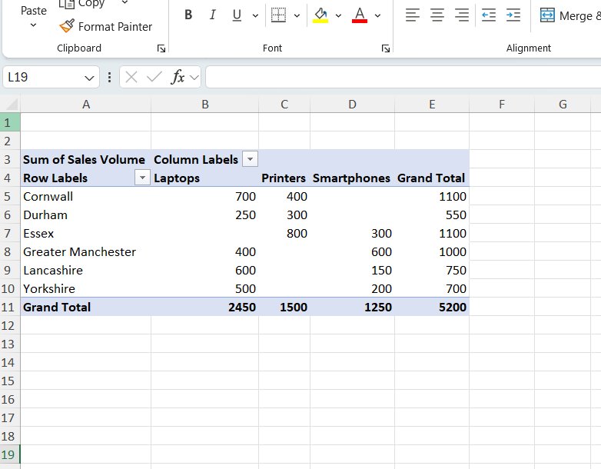  SWITCH column:  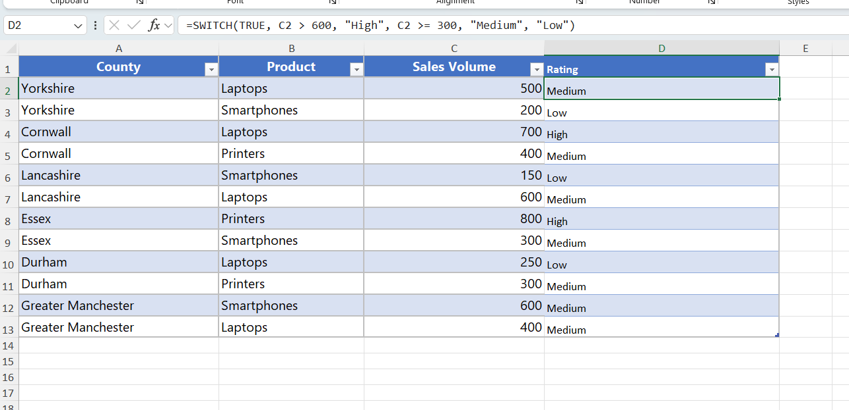

Day 3: Task 3

Please download the dataset ‘Day_3_Task_3_Bike_Sales_Visualisations_Lab.xlsx’.
Also, download the lab instructions.

Pivot tables are already created; you will need to create the pivot charts.

Follow the lab instructions.

Do not worry if you do not complete the lab; just working with data and playing with the charts will be a good experience.

Please paste your results below:

Print screen 1 | 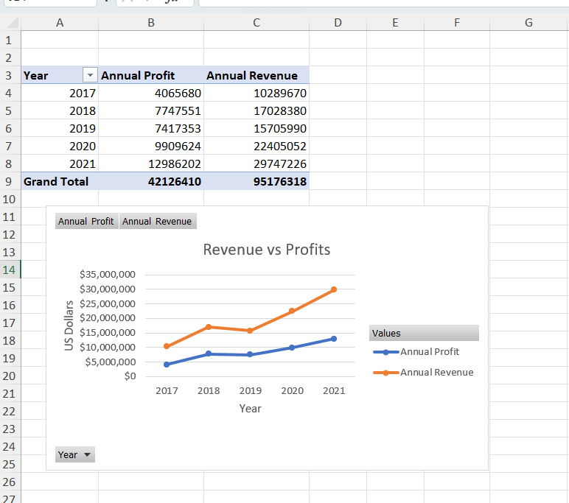  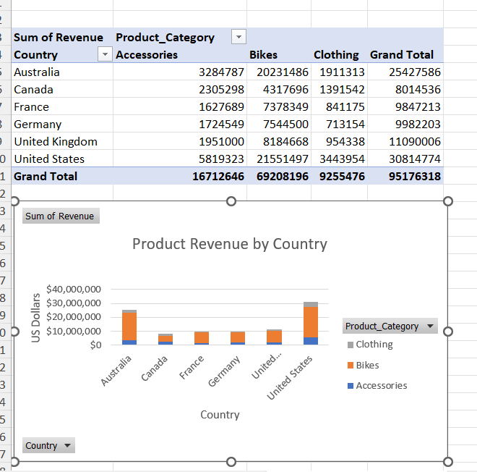  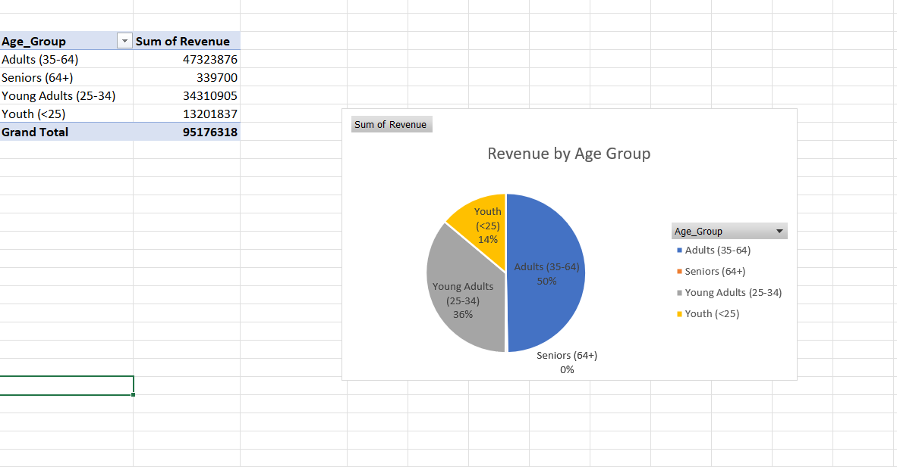

Day 4: Task 1

You have been asked to deliver your analysis findings to the board of directors. Within your analysis, you have identified that customers are leaving your company at the 12-month point, which is typically when they receive their renewal price.

Choose a business or organisation to focus your findings on.

Conduct research and complete the following questions:

As in all work situations, you can use AI Gen tools for research: it needs to be in British English, check spelling, grammar and maths; and written in your voice, not copied directly from the tool.

How would you prepare for the delivery? | Before presenting my findings to the Direct Line board, I would compile my data in easy-to-read formats (such as pivot tables or graphs) and sum up my findings into bullet points. Ideally, this will fit onto a page or two, so that busy board members are able to quickly get a sense of the situation. I would plan what I wanted to say and rehearse it, perhaps writing flashcards with topics I wanted to raise. I would want to avoid reading off paper or a phone to appear well-prepared and authoritative on the subject matter.
What tools would you use for the delivery? | After analysing the data in a programme such as Excel, I would take out the key findings and put these into Word documents, which could be printed out and given to board members. I would also email PDFs of the same information beforehand.  During the delivery itself, I would want to present the information in a PowerPoint presentation. This would be more of a visual aid and not too information-dense, so as to keep the attention on what I am saying.
What is prospecting, and why would you complete this before your delivery? | In business, prospecting is part of the sales process that involves identifying potential customers or leads. With this particular example, I could identify the point at which Direct Line customers are about to leave and identify the existing customers that are just about to reach this point — the sales team could contact these people directly to convince them to stay on, perhaps by presenting a more desirable renewal rate.  Ultimately, the main aim of the data analysis in this case is to prevent customers from leaving Direct Line and joining a competitor, so prospecting would be focused on pinpointing the existing Direct Line service users likely to leave.  https://www.indeed.com/career-advice/career-development/prospecting
Tell me the best practices for public speaking and providing updates to senior leaders | Prepare thoroughly by looking through the analysed data and the materials to be shared with the meeting members. Identify the key messages that you want to get across and memorise these, perhaps writing them on a discrete flashcard to be used during the presentation. When speaking, do so slowly and clearly so as to be best understood. Regularly ask if anybody has any questions to be sure your audience is following your presentation.  https://www.forbes.com/sites/hillennevins/2023/11/12/refine-your-executive-presence-how-to-communicate-strategically/
What will you show the board in your delivery? | I would give each board member a print-out of the relevant customer retention figures arranged in tidy pivot tables and graphs, with key summations in bullet points underneath. The data will show the average customer journey with Direct Line, including the most common timeframe in which they leave the company — this will correlate with the point at which they’re presented with a renewal quote, which can spark discussion among those in charge of business strategy about whether they need to make renewal quotes more attractive in order to retain customers.
How will you articulate the changes that are needed? | As a data analyst, it’s important to make recommendations based only on evidence, so I will justify my suggested changes using the data reports I have compiled. For example, I might have found that customers are more likely to retain the services of First Direct if the renewal quote doesn’t increase by any more than 5%, in which case, I would recommend ensuring renewal quotes do not rise above that.
Provide a list of online resources and videos that will support your preparation for public speaking | https://www.forbes.com/sites/hillennevins/2023/11/12/refine-your-executive-presence-how-to-communicate-strategically/  https://podcasts.apple.com/gb/podcast/think-fast-talk-smart-communication-techniques/id1494989268  https://mindfulpresenter.com/learning-centre/
Evaluate tools that provide visualisation.  Tell me what they are.  Tell me what you would choose when delivering your presentation and why | Excel is a good, if limited, option for data visualisation, as large datasets can be put into customisable pivot tables or graphs. I could also use Power BI or Tableau for more complex data visualisation.  In the presentation itself, I might want to use the Adobe suite to create well-laid-out pages containing relevant data and graphs to illustrate the points I wish to make. A PowerPoint presentation could also be useful as a way of adding further information to my spoken points. These tools are both for presentation purposes only and cannot be used to analyse data.

Course Notes

It is recommended to take notes from the course, use the space below to do so.

Additional Information

We have included a range of additional links to further resources and information that you may find useful, these can be found within your revision guide.

END OF WORKBOOK

Please check through your work thoroughly before submitting and update the table of contents if required.

Please send your completed work booklet to your trainer.

